Sharing Economy Platform
Use Case Document


 | Prepared By / Last Updated By | Reviewed by | Reviewed by | Approved By
Name | Mahima Suri | Vinita Singh | Shashwat Jain | Vinay Agnihotri
Role | Team Member | Team Member | Team Member | Scrum Master
Signature | Mahima Suri | Vinita Singh | Shashwat Jain | Vinay Agnihotri
Date | 15-Apr-2019 | 15-Apr-2019 | 15-Apr-2019 | 15-Apr-2019

Table of Contents
1.0 Introduction 3
1.1 Purpose & Scope of the document 3
1.2 Intended Audience 3
1.3 Use case ‘User Registration’ 3
1.3.1 Use case attributes 3
1.3.2 Business Rules 4
1.3.3 UI Requirements 4
1.3.4 UI Field Validations 5
1.4 Use case ‘User Credential Authentication’ 5
1.4.1 Use case attributes 5
1.4.2 Business Rules 6
1.4.3 UI Requirements 6
1.5 Use case ‘Vendor Registration’ 7
1.5.1 Use case attributes 7
1.5.2 Business Rules 8
1.5.3 UI Requirements 8
1.5.4 UI Field Validations 9
1.6 Use case ‘Record Bill’ 9
1.6.1 Use case attributes 9
1.6.2 Business Rules 10
1.6.3 UI Requirements 11
1.6.4 UI Field Validations 11
1.7 Use case ‘Pending Bills’ 11
1.7.1 Use case attributes 11
1.7.2 Business Rules 12
1.7.3 UI Requirements 12
1.8 Use case ‘Bill Payment’ 13
1.8.1 Use case attributes 13
1.8.2 Business Rules 14
1.8.3 UI Requirements 14
2.0 Database Design 16
2.1 Tables Structure 17
3.0 Data Flow Diagram 18

Introduction

Purpose & Scope of the document
The purpose of this Use case document is to systematically capture requirements for the project and the system to be developed in terms of use cases. Functional use cases are captured in this document. It also serves as the input for the project scoping.

The scope of this document is limited to addressing the use cases from a user, quality, and non-functional perspective.

Intended Audience
Each member of the project team

Use case ‘User Registration’

Use case attributes
Use Case Description:

This use case deals with the capture of user details. The ‘user’ here shall be the operator of the system and will be keying in the user details.

Scope:

- User registration

Actors:

- User – the operator

Trigger:

Click ‘Sign Up’ button in the ‘User Registration’ page

Pre-Condition:

User being able to access the homepage & get redirected to the ‘User Registration’ page upon click of ‘New User?’ link on the home page.

Post Condition:

User is in the registration page & submit details.

Flow of Events:

User at homepage → Click ‘New User?’ link → User is in the registration page → User details are submitted and added onto the database.

Primary Scenario:
A new user – is able to click ‘New User?’ link and able to provide his details and get registered in the system.

Business Rules
Business rules should be defined using the following attributes: -

- When the user clicks on the register link, it should re-direct to registration form.
    - User needs to fill some of the basic attributes/fields as mentioned below in requirement: First Name, Last Name, Age, Gender, Contact Number, User Id and Password.
- Clicking ‘Sign Up’ should validate the datatype constraints for each field
- Post-successful field level validation, save the information in the database
- Upon saving the information in the database, display the message ‘Your have successfully registered’.

UI Requirements
Here is a prototype on how the login page should look like.

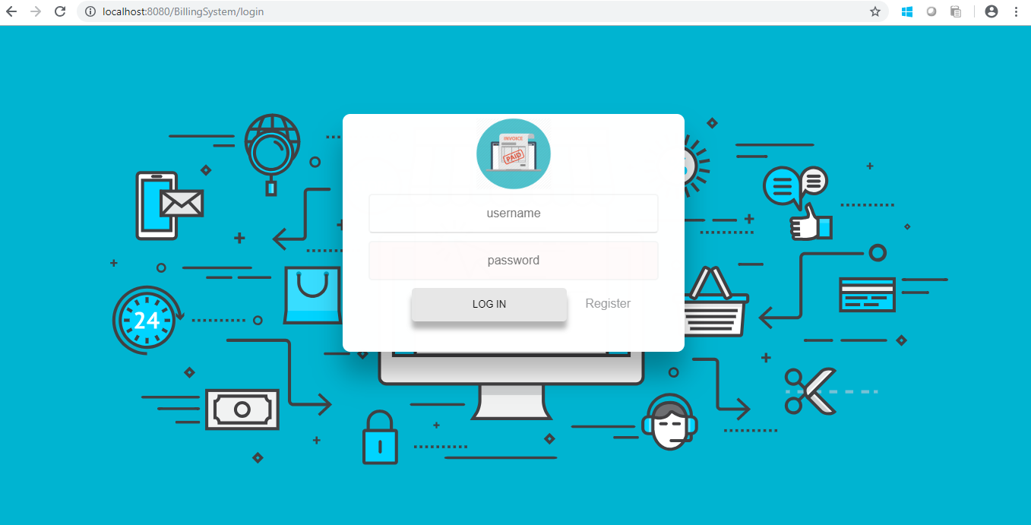

SEP_Pic-2.0 Login page

Here is a prototype on how the ‘User Registration’ page should look like.

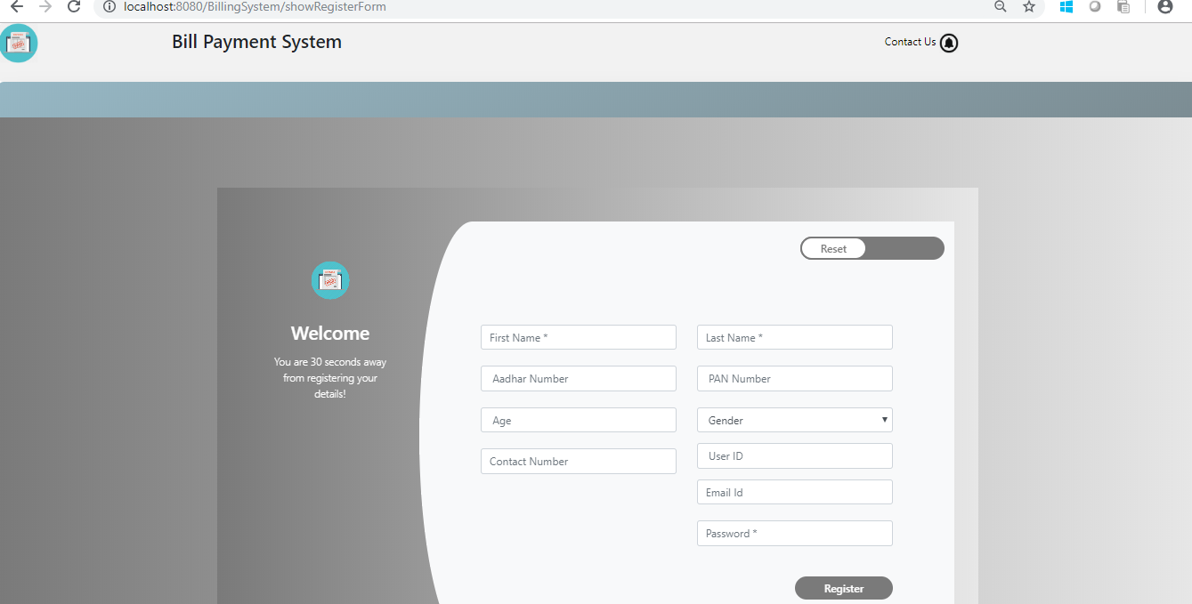

SEP_Pic-3.0 Registration Form of User

UI Field Validations
Please refer to the below requirements for field level validations:

- All fields are mandatory.
- First Name, Last Name should contain only alphabets
- Age should be two-digit numeric value.
- Gender should be chosen from the dropdown options
- Contact Number must be of 10 digit length.
- User ID must be unique among all the users.
- Password should have minimum 8 alphanumeric, space or special characters (ex: !, @,#,%,*,& )

Use case ‘User Credential Authentication’

Use case attributes
Use Case Description:

This use case deals with the authentication of the existing user credentials. The ‘user’ here shall be the operator of the system and will be keying in the user information into the system.

Scope:
- User credentials authentication
Actors:
User – the operator

Trigger:

Click ‘Login’ link, after keying in ‘Username’ & ‘Password’ field.

Pre-Condition:

User being able to access the home page

Post Condition:

User is in the User Main Page.

Flow of Events:

User at homepage → User at login form on left → Key in ‘Username’ & ‘Password’ field → User clicks ‘Login’ button → User credentials are validated → User Main Page is displayed.

Primary Scenario:
A registered user – is able click ‘Login’ link, after keying in ‘Username’ & ‘Password’ field and get his credentials authenticated with the existing database entry.

Alternative Scenario:
A registered user – is able click ‘Login’ link, after keying in ‘Username’ & ‘Password’ field and unable to get his credentials authenticated. The user is presented with relevant error messages: Invalid username or password.

Business Rules
Business rules should be defined using the following attributes: -

- The ‘Username’’ & ‘Password’ entered by the user must match a record in the existing database entry for successful authentication.

UI Requirements
Here is a prototype on how the User Main Page page should look like.

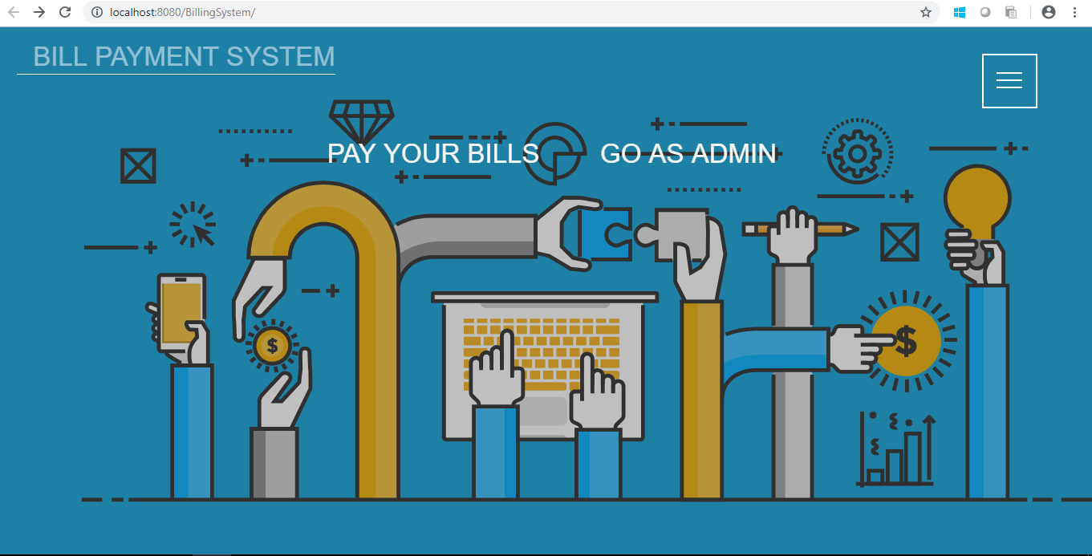

SEP_Pic-1.0 Home Page

Use case ‘Vendor Registration’

Use case attributes
Use Case Description:

This use case deals with the capture of vendor details. The ‘vendor’ here shall be the operator of the system and will be keying in the vendor details.

Scope:

- Vendor Registration

Actors:

- Vendor – the operator

Trigger:

Vendor should be redirected to the ‘Vendor Registration’ page upon clicking on the ‘Existing Vendor’ link.

Pre-Condition:

Vendor should be able to get redirected to the ‘Vendor Registration’ page upon clicking the ‘New Vendor?’ link on the home page.

Post Condition:

Vendor is in the registration page & submit vendor details.

Flow of Events:

User at homepage → Click ‘New Vendor?’ link →Vendor on Vendor Registration Page → Vendor fills in details and click on ‘Sign Up’ button → Vendor details are submitted and added onto the database

Primary Scenario:
Vendor – is able to click ‘New Vendor?’ link and able to provide vendor details and get vendor registered into the system.

Here is a prototype on how the vendor Registration should look like.

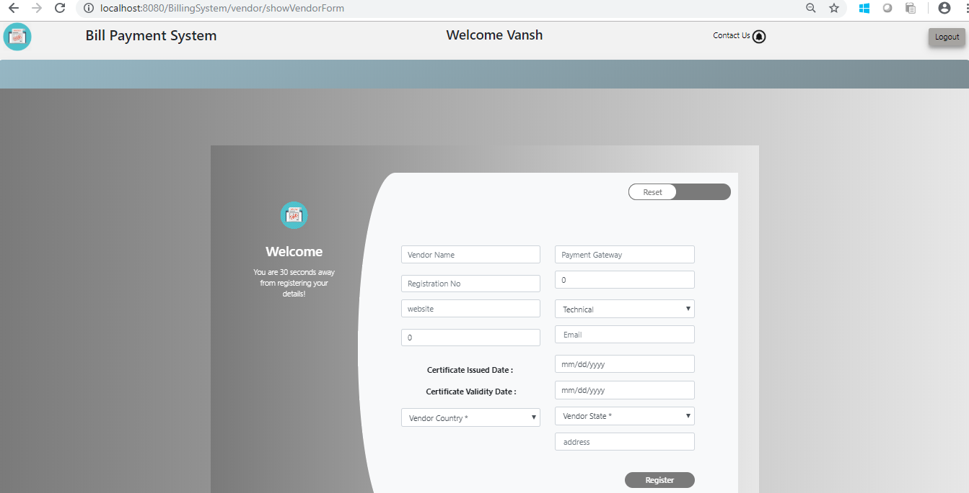

SEP_Pic-5.0 Vendor Registration Page

Business Rules

Business rules should be defined using the following attributes: -

- When the vendor clicks on the register link, it should re-direct to registration form.
    - Vendor needs to fill some of the basic attributes/fields as mentioned below in requirement: First Name, Last Name, Age, Gender, Contact Number, User Id and Password.
- Clicking ‘Sign Up’ should validate the datatype constraints for each field
- Post-successful field level validation, save the information in the database
- Upon saving the information in the database, display the message ‘Your have successfully registered’.

UI Requirements
Here is a prototype on how the Vendor page should look like.

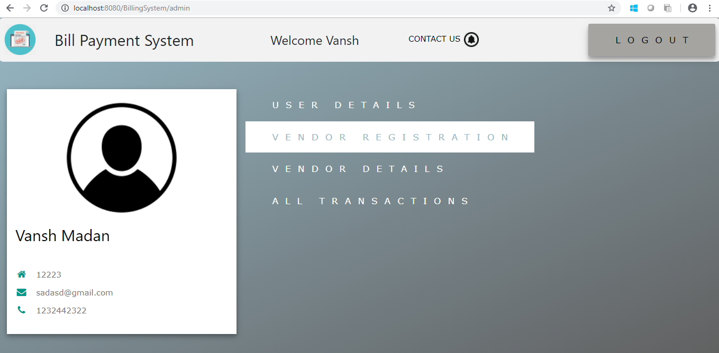

SEP_Pic-4.0 Vendor Page

UI Field Validations
Please refer to the below requirements for field level validations:

- All fields are mandatory.
- First Name, Last Name should contain only alphabets
- Age should be two-digit numeric value.
- Gender should be chosen from the dropdown options
- Contact Number must be of 10 digit length.
- User ID must be unique among all the vendors.
- Password should have minimum 8 alphanumeric, space or special characters (ex: !, @,#,%,*,& )

Use case ‘Vendor Credential Authentication’

Use case attributes
Use Case Description:

This use case deals with the authentication of the existing vendor credentials. The ‘vendor’ here shall be the operator of the system and will be keying in the vendor information into the system.

Scope:
- Vendor credentials authentication
Actors:
Vendor – the operator

Trigger:

Click ‘Login’ link, after keying in ‘User ID’ & ‘Password’ field.

Pre-Condition:

Vendor being able to access the home page

Post Condition:

Vendor is in the Vendor Main Page.

Flow of Events:

Vendor at homepage → Vendor clicks on ‘Existing Vendor’ button → Vendor redirected to Vendor Login Page→ Key in ‘User ID’ & ‘Password’ field → Vendor clicks ‘Login’ button → Vendor credentials are validated → Vendor Main Page is displayed.

Primary Scenario:
A registered Vendor – is able click ‘Login’ link, after keying in ‘Username’ & ‘Password’ field and get his credentials authenticated with the existing database entry.

Alternative Scenario:
A registered Vendor – is able click ‘Login’ link, after keying in ‘Username’ & ‘Password’ field and unable to get his credentials authenticated. The Vendor is presented with relevant error messages: Invalid username or password.

Business Rules
Business rules should be defined using the following attributes: -

- The ‘Username’’ & ‘Password’ entered by the Vendor must match a record in the existing database entry for successful authentication.

UI Requirements
Here is a prototype on how the Vendor Main Page page should look like.

SEP_Pic-1.0 Home Page

Use case ‘Record Vendor Details’

Use case attributes
Use Case Description:

This use case deals with the ability to record further vendor details. The ‘vendor’ here shall be the operator of the system and will be keying in the vendor record(registration) details.

Scope:

- Record vendor details

Actors:

- Vendor – the operator

Trigger:

Click ‘Update’ button in the ‘Update Personal Detail’ page

Pre-Condition:

Vendor being able to access the ‘Vendor Main’ page. Vendor being able to reach ‘Update Personal Detail’ page upon clicking link on the menu on left. Once the details have been successfully entered, Vendor is given the option ‘Update’ to save the entered details in the database.

Post Condition:

Vendor is displayed a popup displaying the message “Bill Form Saved Successfully” and is redirected to the initial ‘Record Your Bill’ page.

Flow of Events:

Vendor at homepage → Vendor clicks on ‘Existing Vendor’ button → Vendor redirected to Vendor Login Page→ Key in ‘User ID’ & ‘Password’ field → Vendor clicks ‘Login’ button → Vendor credentials are validated → Vendor Main Page is displayed → clicking on Update Personal Detail link Vendor being able to reach ‘Update Personal Detail’ page →Vendor enters the details →
Details are added onto the database upon clicking the ‘Update’-> Vendor redirected to ‘View Details Page’.

Primary Scenario:
A vendor – is able to click ‘Update Personal Detail’ link and able to provide his details.

Business Rules

Business rules should be defined using the following attributes: -

- When the vendor clicks on the register link, it should re-direct to registration form.
    - Vendor needs to fill the following attributes/fields as mentioned below in requirement: Address, City, Zip code, Landline, Email, and Detailed Info.
- Clicking ‘Update’ should validate the datatype constraints for each field
- Post-successful field level validation, save the information in the database.

UI Requirements
Here is a prototype on how the ‘Bill Pay” page should look like.

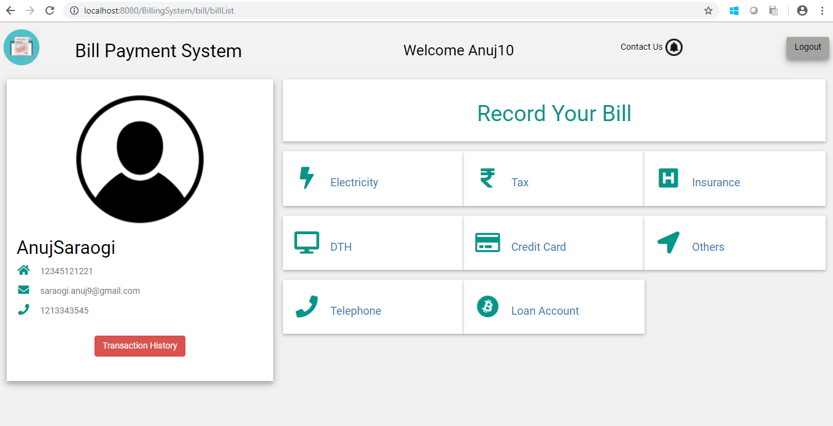

SEP_Pic-7.0 Bill Pay Page

UI Field Validations
Please refer to the below requirements for field level validations:

- All fields are mandatory.
- Zip code should contain only numeric digits.
- Landline should contain only numeric digits.
- Email should be in a valid format.

Use case ‘Record Product/Service details’

Use case attributes
Use Case Description:

These use case deals with the ability of the system to provide information about adding a product/service details for a given Vendor of the given selected type by the Vendor. The ‘Vendor’ here shall be the operator of the system and shall select the category.

Scope: Adding Product/Service details

Actors:

- Vendor– the operator
Trigger:

Click ‘Add Product‘ link and select the suitable category Product or Service from the dropdown menu option.

Pre-Condition:

Vendor being able to reach ‘Add Product‘ page upon clicking ‘Add Product’ link.

Post Condition:

Vendor is in the ‘View Product‘ page where all the products/services offered by the Vendor are listed.

Flow of Events:

Vendor at Vendor Main Page → Click ‘Update Product Details’ link → Vendor at add your product page→ Select category: Product or Service (dropdown) →Get sub-category (dropdown) depending on previous selection → Vendor is able is to add details in fields provided → Click on ‘Add Product/Service’ Button→ Product/Service updated in database according to category.

Primary Scenario:
A vendor is able to add product/services with the details that he/she offers.

Business Rules
Business rules should be defined using the following attributes: -

- Vendor should have the option to select the type as Product or service.
- All category divisions available should be listed for the Product / Service and Vendor should be able to select one
- Clicking ‘Add’ should validate the datatype constraints for each field.
- Based on the category selected by the vendor the system should save the details of the product entered in the database.
- Provide vendor failing to provide information on the mandatory fields with an alert message – ‘Please update the highlighted mandatory field(s).’ Also, highlight the missed out field in red

UI Requirements
Here is a prototype on to reach Add Product details .

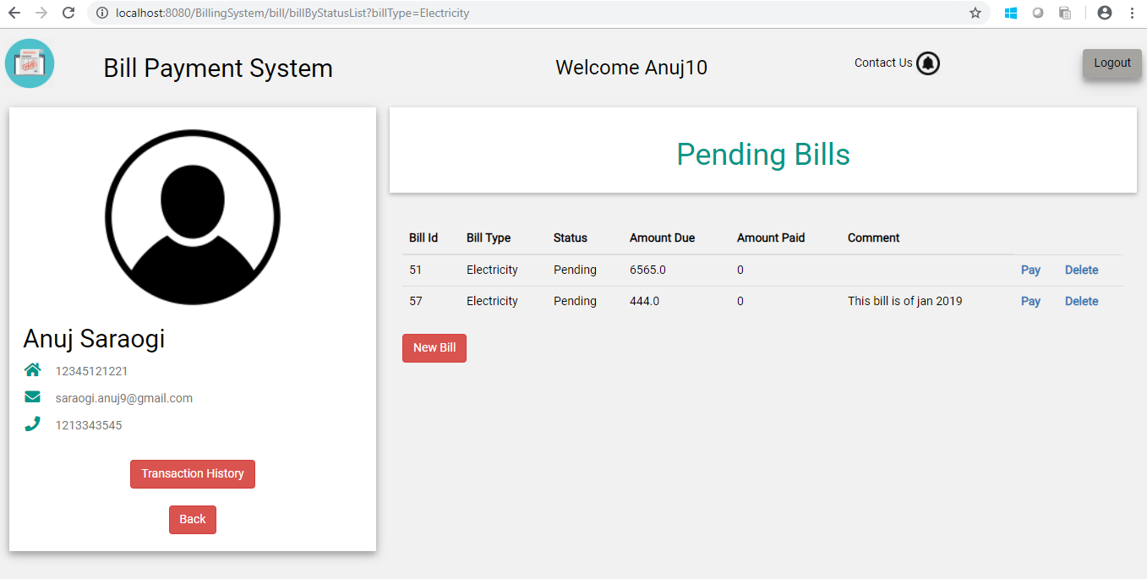

SEP_Pic-8.0 Adding Product Details

Use case ‘Display Product/ Service’

Use case attributes
Use Case Description:

This use case deals with the ability of the user to view the Product / Services available based on the category .The ‘user’ here shall be the operator of the system and will be keying in the category details.

Scope:

Display Product/Service.

Actors:

- User – the operator

Trigger:

Click ‘View Product’ button in the User main page .

Pre-Condition:

Vendor being able to access the ‘Vendor Main’ page. Vendor being able to reach ‘Add product’ page upon clicking link on left is redirected to the new product/service addition form where vendor can register the details of the given item type against the given fields like product/service type and description. Once the details have been successfully entered, user is given the option ‘Add’ to save the entered details in the database.

Post Condition:

User is displayed a popup displaying the message “Product added successfully”.

Flow of Events:

User at User Main page → Click ‘View Product’ link → User has to select category from dropdown menu (Product/Service)→ Based on previous selection get another dropdown to select the subcategories→User clicks on view button
->User is able to view the product/service details that match his/her requirement.

Primary Scenario:
A user – is able to click view button and is able to see all the product/service available.

Business Rules
Business rules should be defined using the following attributes: -

    - User needs to click on any of the product/service types and should be able to see all the product/service details of the selected category.

UI Requirements
Here is a prototype to View Product/Service on clicking View button -

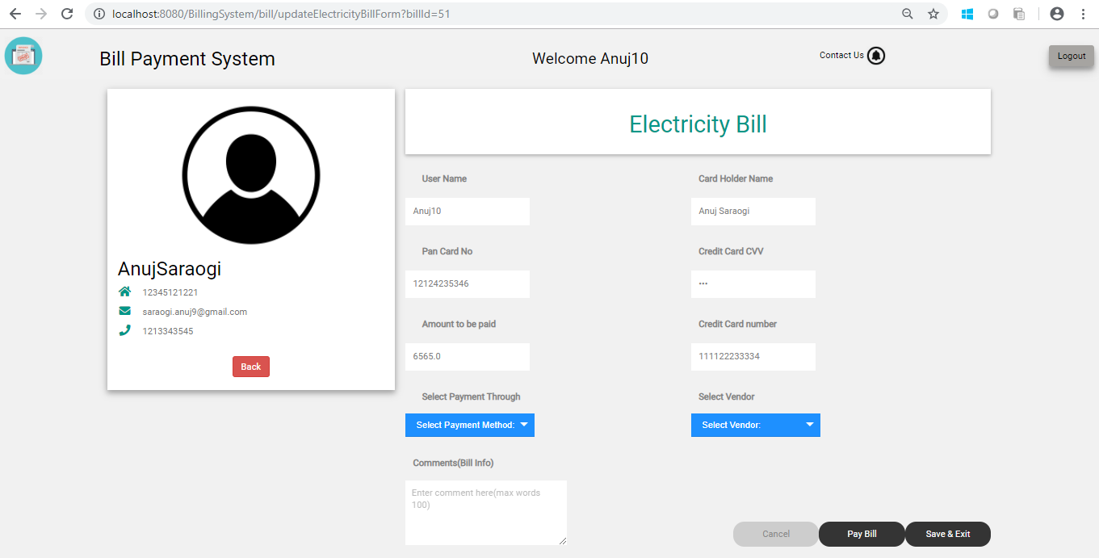

SEP_Pic-9.0 Recorded Bill Form

Here is a prototype of Bill Payment Page with Pay Bill button if a user select a new bill to be payed –

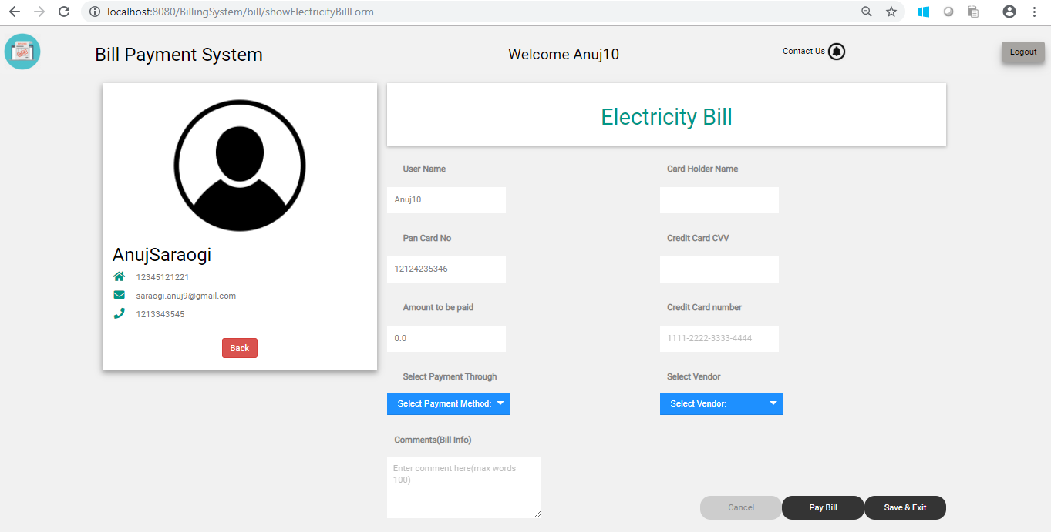

SEP_Pic-10.0 New Bill Form

Use case ‘Logoff’

Use case attributes
Use Case Description:

This use case deals with the ability of the user to logoff

Scope:

Logoff.

Actors:

- Vendor/User – the operator

Trigger:

Click logoff button.

Business Rules
Business rules should be defined using the following attributes: -

    - User needs to click on logoff button.

UI Requirements
Here is a prototype to logoff on clicking logoff button

Database Design

Tables Structure
User Details:
Column Name | Field Type | Data Type | Mandatory
First Name | Text(50) | Alphabetic | Yes
Last Name | Text(50) | Alphabetic | Yes
Age | Numeric(2) | Numeric | Yes
Gender | Drop Down | NA | Yes
Contact Number | Text(10) | Numeric | No
User ID | Text(15) | Alphanumeric | Yes
Password | Text(15) | Alphanumeric | Yes

Vendor Details:
Column Name | Field Type | Data Type | Mandatory
First Name | Text(50) | Alphabetic | Yes
Last Name | Text(50) | Alphabetic | Yes
Age | Numeric(2) | Numeric | Yes
Gender | Drop Down | NA | Yes
Contact Number | Text(10) | Numeric | No
User ID | Text(15) | Alphanumeric | Yes
Password | Text(15) | Alphanumeric | Yes

Vendor Registration details:
Column Name | Data Type | Length | Mandatory
Vendor User Id | Text(15) | Alphanumeric | Yes
First Name | Text(50) | Alphabetic | Yes
Last Name | Text(50) | Alphabetic | Yes
Gender | Drop Down | NA | Yes
Contact Number | Text(10) | Numeric | Yes
Vendor ID | Auto-generated(5) | Numeric | Yes
Address | Scrolling text box | Alphanumeric | Yes
City | Text(50) | Alphabetic | Yes
Zip Code | Text(10) | Numeric | Yes
Landline | Text(10) | Numeric | No
E Mail | Text(50) | Alphanumeric | Yes
Other contact info | Text(100) | Alphanumeric | No

Product Details:
Column Name | Field Type | Data Type | Mandatory
Product_Id | Number(10) | Numeric | Yes
Type1 | Varchar2(20) | Alphabetic | Yes
Type2 | Varchar2(20) | Alphabetic | Yes
Length | Number(10) | Numeric | Yes
Breadth | Number(10) | Numeric | Yes
Height | Number(10) | Numeric | Yes
Color | Varchar2(50) | Alphabetic | Yes
Material | Varchar2(50) | Alphabetic | Yes
Brand | Varchar2(50) | Alphabetic | Yes
Price | Number(15) | Numeric | Yes
Description | Varchar2(200) | Alphabetic | Yes

Service Details:
Column Name | Field Type | Data Type | Mandatory
Service_Id | Number(10) | Numeric | Yes
Type1 | Varchar2(20) | Alphabetic | Yes
Type2 | Varchar2(20) | Alphabetic | Yes
Price | Number(15) | Numeric | Yes
Description | Varchar2(200) | Alphabetic | Yes

Data Flow Diagram
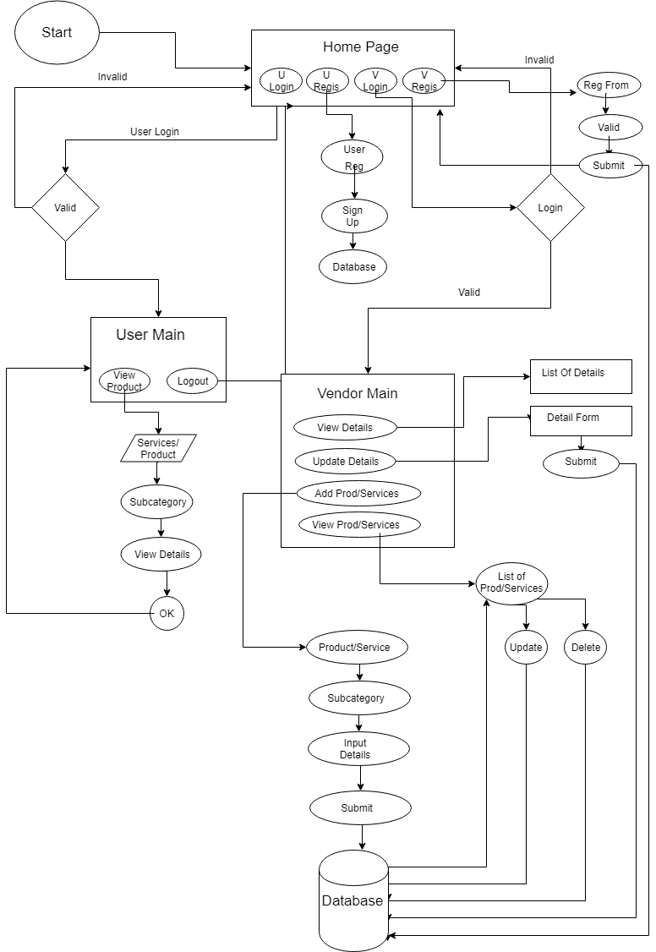
SEP_Pic-11.0 Overview of Bill Payment System

